1. Flight Trajectory Calculation

Pointers: Use to traverse the trajectory array.

Arrays: Store trajectory points (x, y, z) at discrete time intervals.

Functions: void calculate_trajectory(const double *parameters, double *trajectory, int size): Takes the initial velocity, angle, and an array to store trajectory points.

void print_trajectory(const double *trajectory, int size): Prints the stored trajectory points.

Pass Arrays as Pointers: Pass the trajectory array as a pointer to the calculation function.

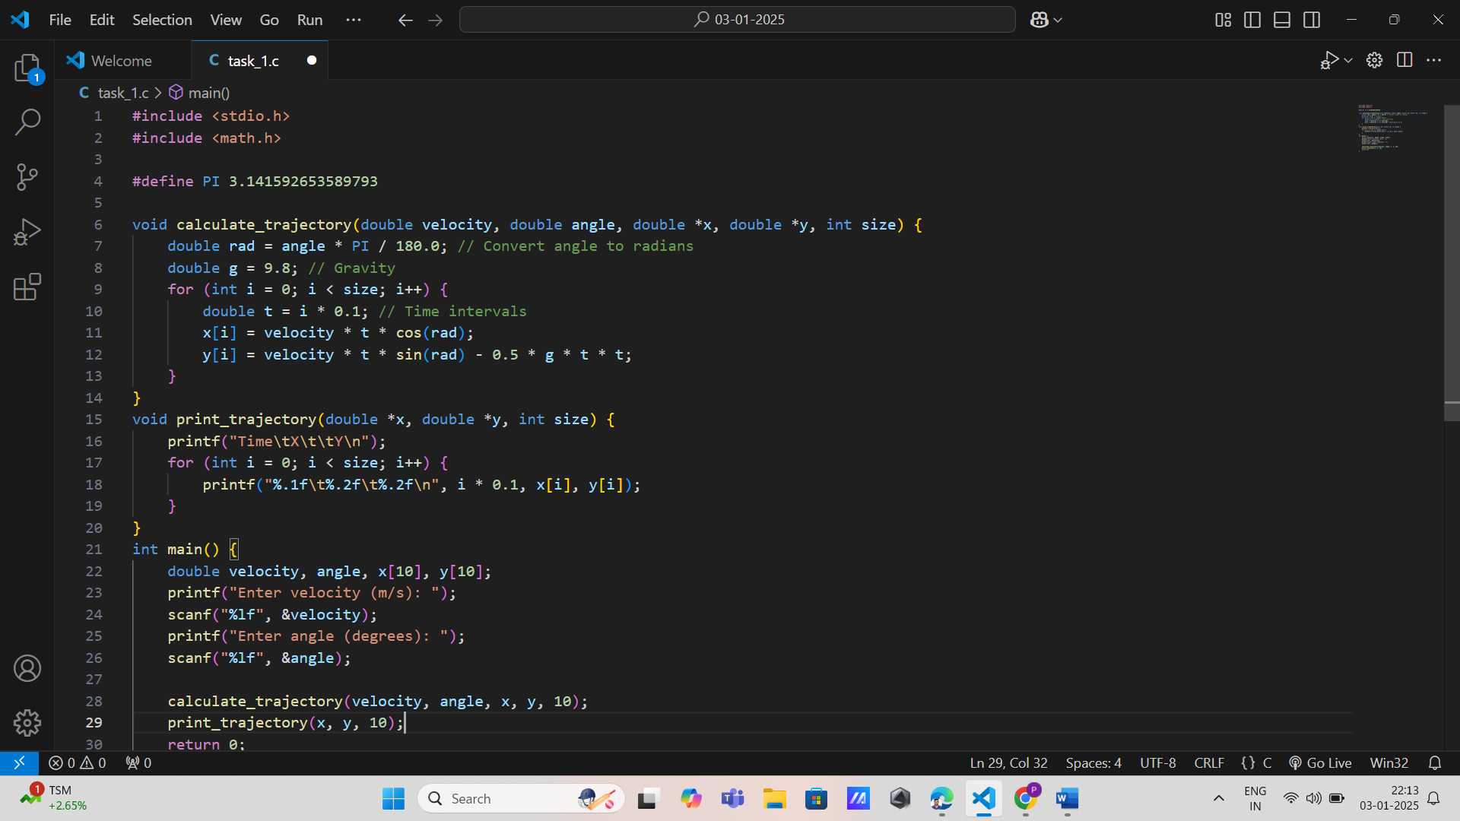

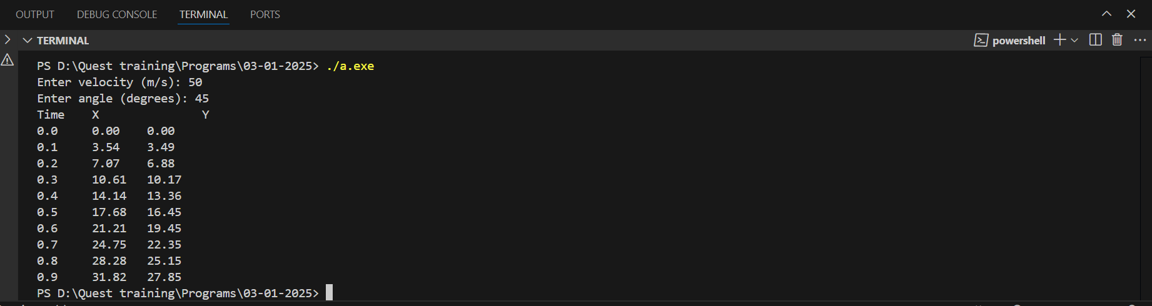

2. Satellite Orbit Simulation

Pointers: Manipulate position and velocity vectors.

Arrays: Represent the satellite's position over time as an array of 3D vectors.

Functions:void update_position(const double *velocity, double *position, int size): Updates the position based on velocity.

void simulate_orbit(const double *initial_conditions, double *positions, int steps): Simulates orbit over a specified number of steps.

Pass Arrays as Pointers: Use pointers for both velocity and position arrays.

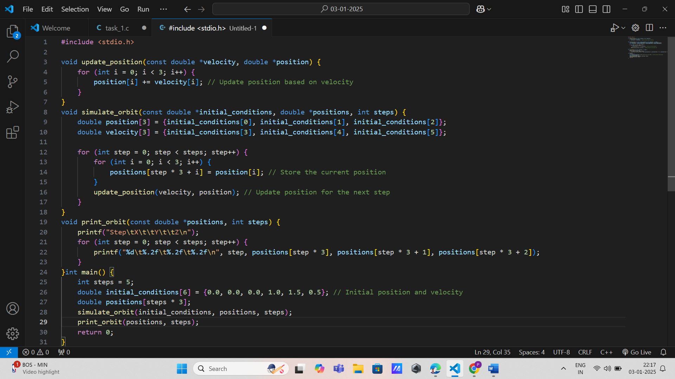

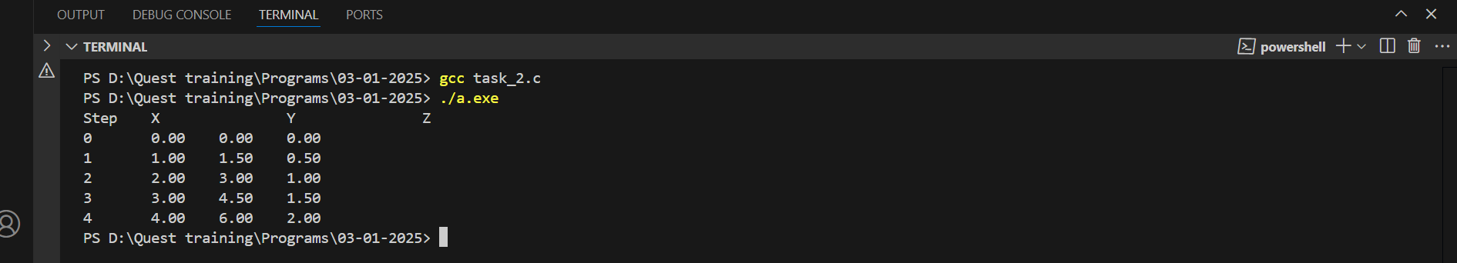

3. Weather Data Processing for Aviation Pointers: Traverse weather data arrays efficiently.

Arrays: Store hourly temperature, wind speed, and pressure.

Functions: void calculate_daily_averages(const double *data, int size, double *averages): Computes daily averages for each parameter. void display_weather_data(const double *data, int size): Displays data for monitoring purposes.Pass Arrays as Pointers: Pass weather data as pointers to processing functions.

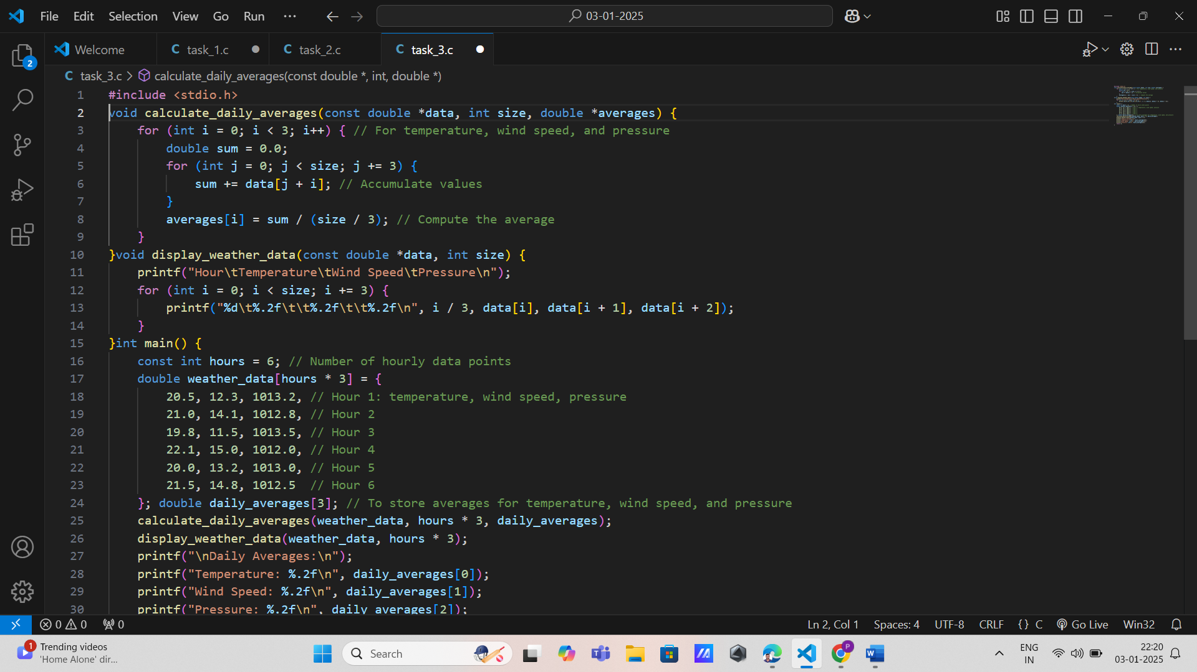

4. Flight Control System (PID Controller)

Pointers: Traverse and manipulate error values in arrays.

Arrays: Store historical error values for proportional, integral, and derivative calculations.

Functions:

double compute_pid(const double *errors, int size, const double *gains): Calculates control output using PID logic.

void update_errors(double *errors, double new_error): Updates the error array with the latest value.

Pass Arrays as Pointers: Use pointers for the errors array and the gains array

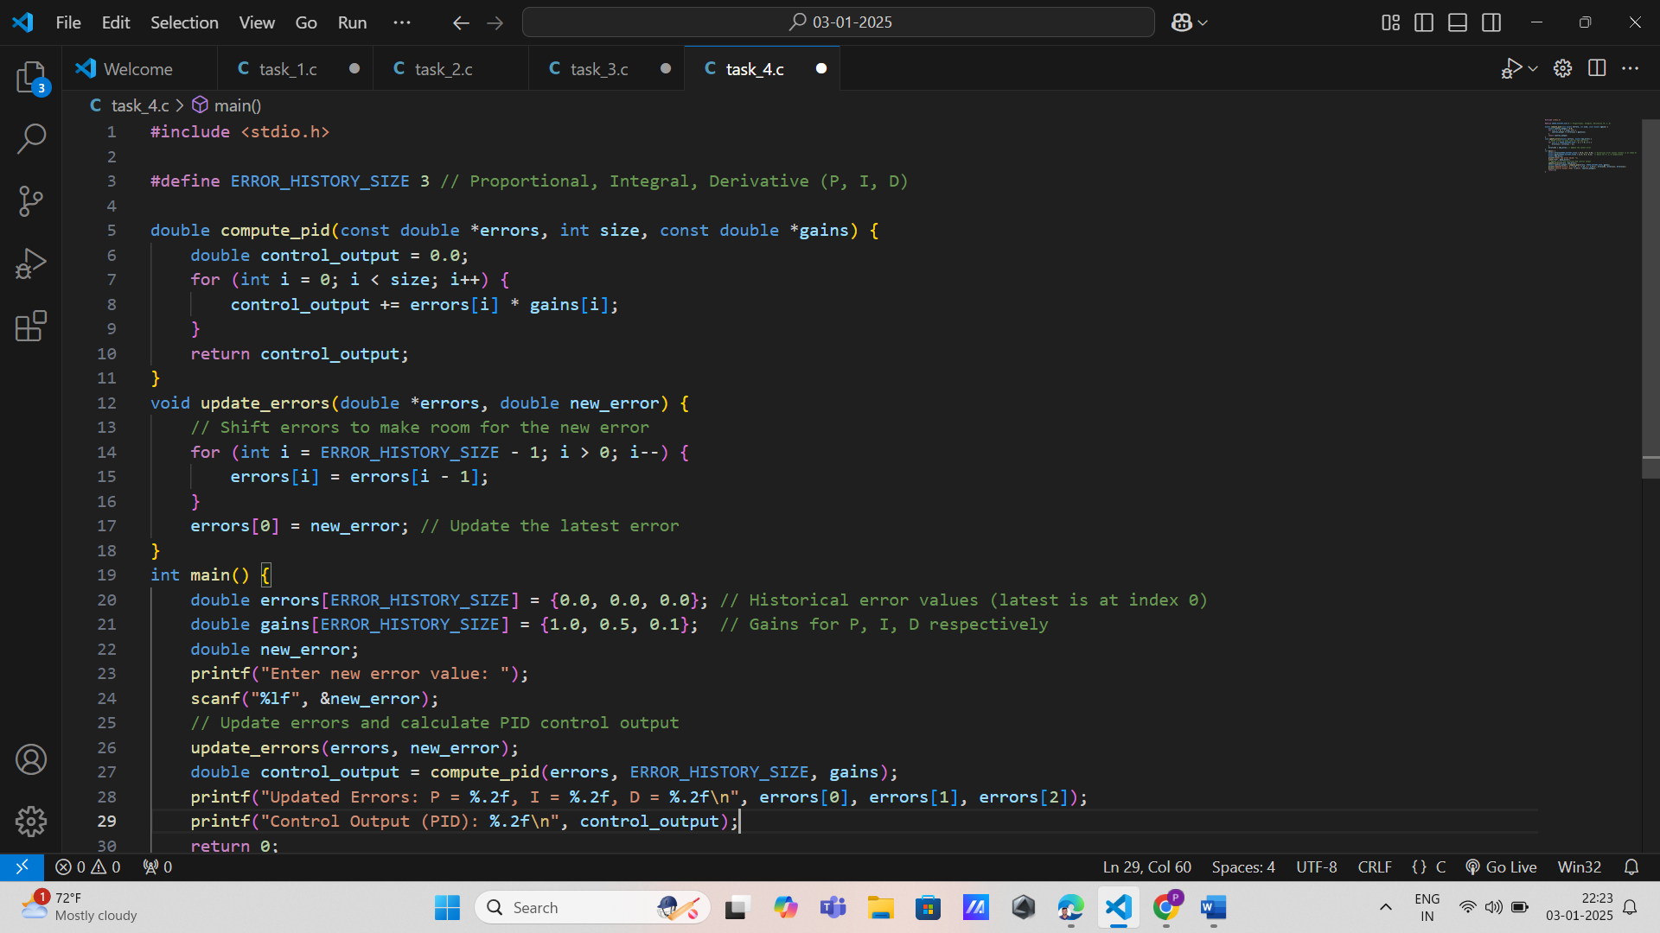

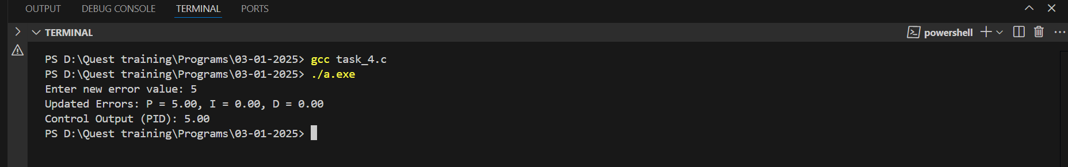

5. Aircraft Sensor Data Fusion

Pointers: Handle sensor readings and fusion results.

Arrays: Store data from multiple sensors.

Functions:

void fuse_data(const double *sensor1, const double *sensor2, double *result, int size): Merges two sensor datasets into a single result array.

void calibrate_data(double *data, int size): Adjusts sensor readings based on calibration data.

Pass Arrays as Pointers: Pass sensor arrays as pointers to fusion and calibration functions.

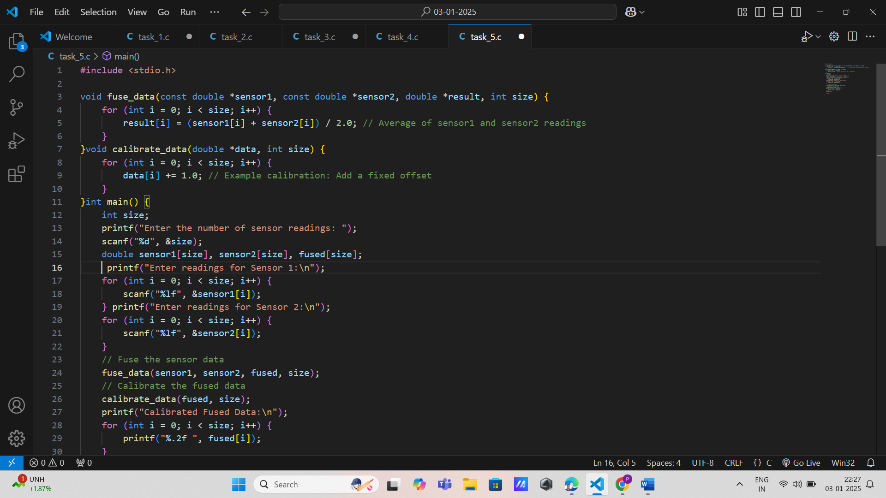

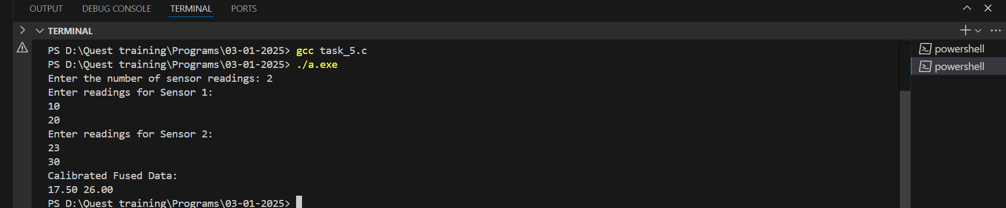

6. Air Traffic Management

Pointers: Traverse the array of flight structures.

Arrays: Store details of active flights (e.g., ID, altitude, coordinates).

Functions:

void add_flight(flight_t *flights, int *flight_count, const flight_t *new_flight): Adds a new flight to the system.

void remove_flight(flight_t *flights, int *flight_count, int flight_id): Removes a flight by ID.

Pass Arrays as Pointers: Use pointers to manipulate the array of flight structures.

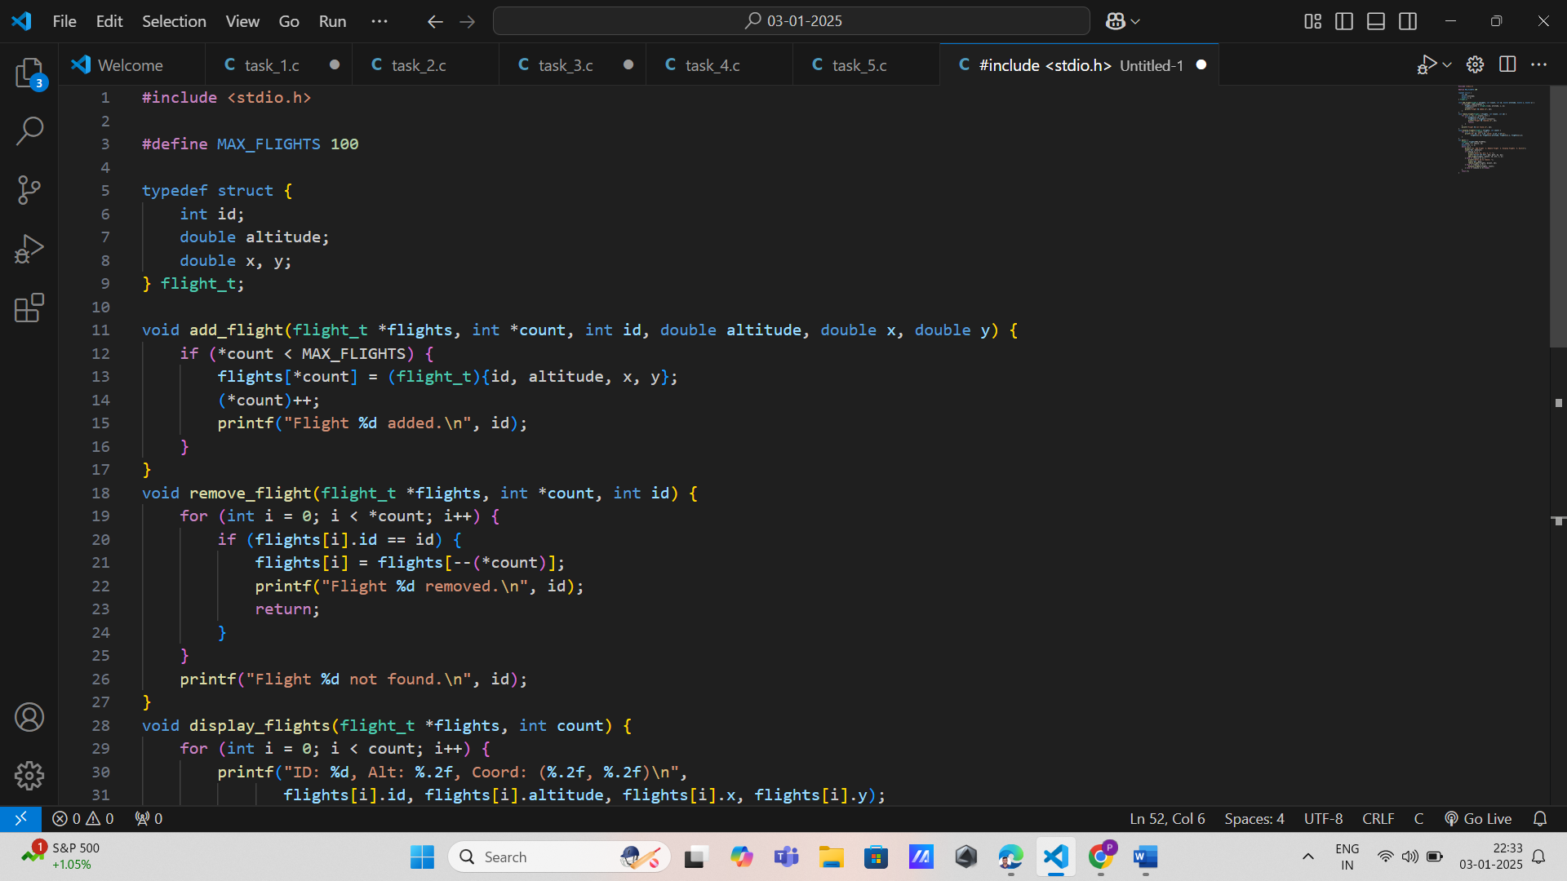

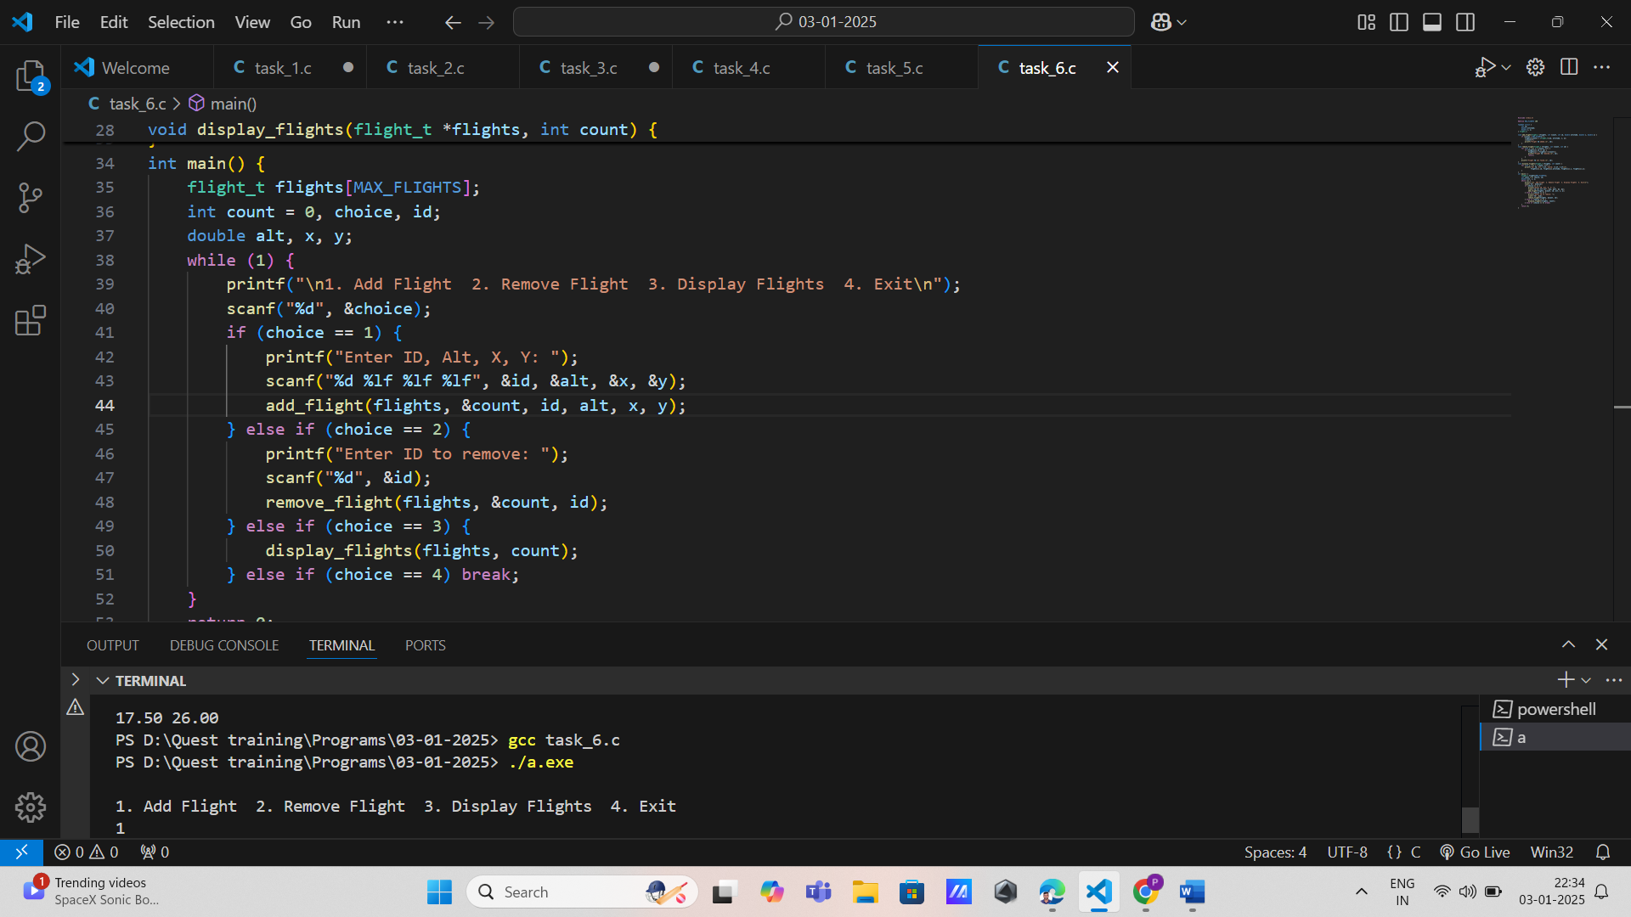

7. Satellite Telemetry Analysis

Pointers: Traverse telemetry data arrays.

Arrays: Store telemetry parameters (e.g., power, temperature, voltage).

Functions:

void analyze_telemetry(const double *data, int size): Computes statistical metrics for telemetry data.

void filter_outliers(double *data, int size): Removes outliers from the telemetry data array.

Pass Arrays as Pointers: Pass telemetry data arrays to both functions.

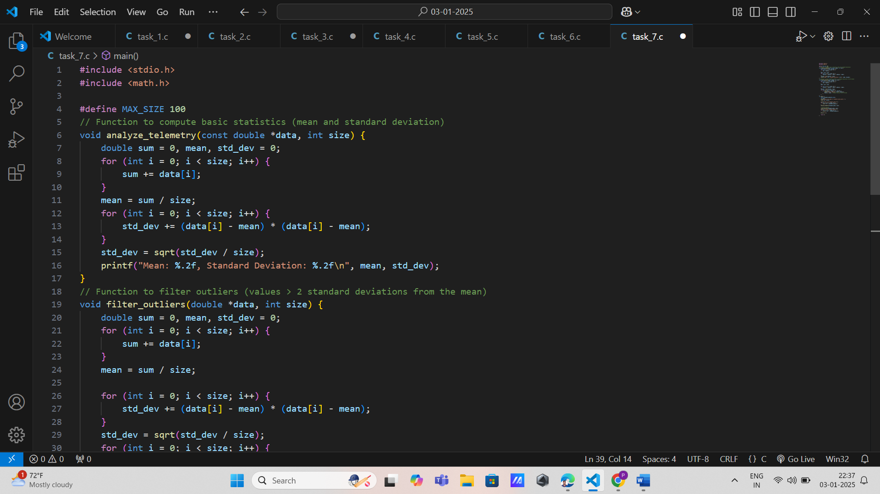

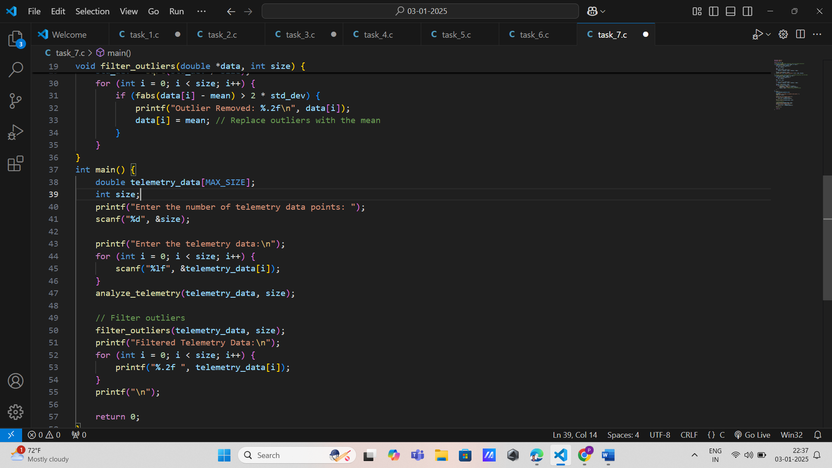

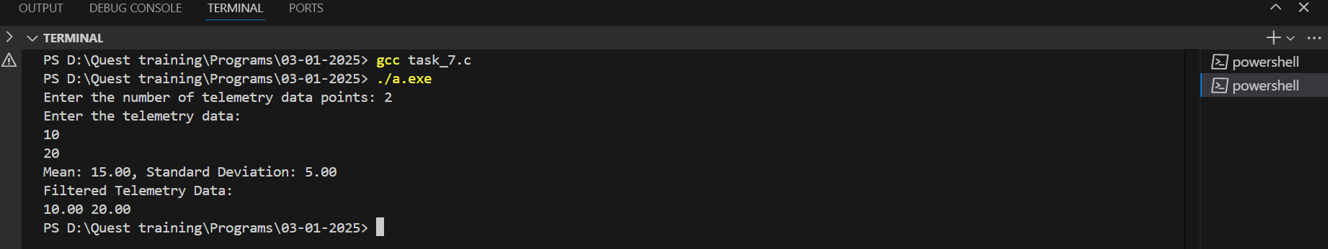

8. Rocket Thrust Calculation

Pointers: Traverse thrust arrays.

Arrays: Store thrust values for each stage of the rocket.

Functions:

double compute_total_thrust(const double *stages, int size): Calculates cumulative thrust across all stages.

void update_stage_thrust(double *stages, int stage, double new_thrust): Updates thrust for a specific stage.

Pass Arrays as Pointers: Use pointers for thrust arrays

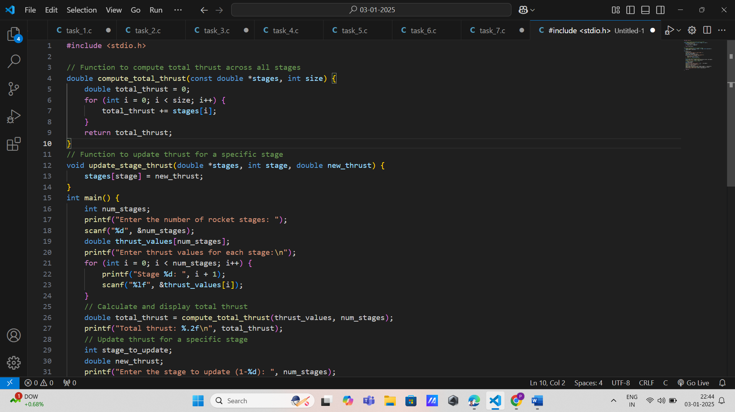

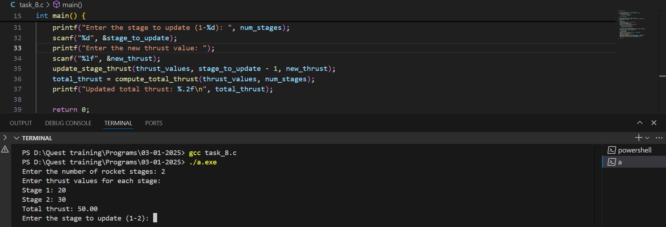

9. Wing Stress Analysis

Pointers: Access stress values at various points.

Arrays: Store stress values for discrete wing sections.

Functions:

void compute_stress_distribution(const double *forces, double *stress, int size): Computes stress values based on applied forces.

void display_stress(const double *stress, int size): Displays the stress distribution.

Pass Arrays as Pointers: Pass stress arrays to computation functions.

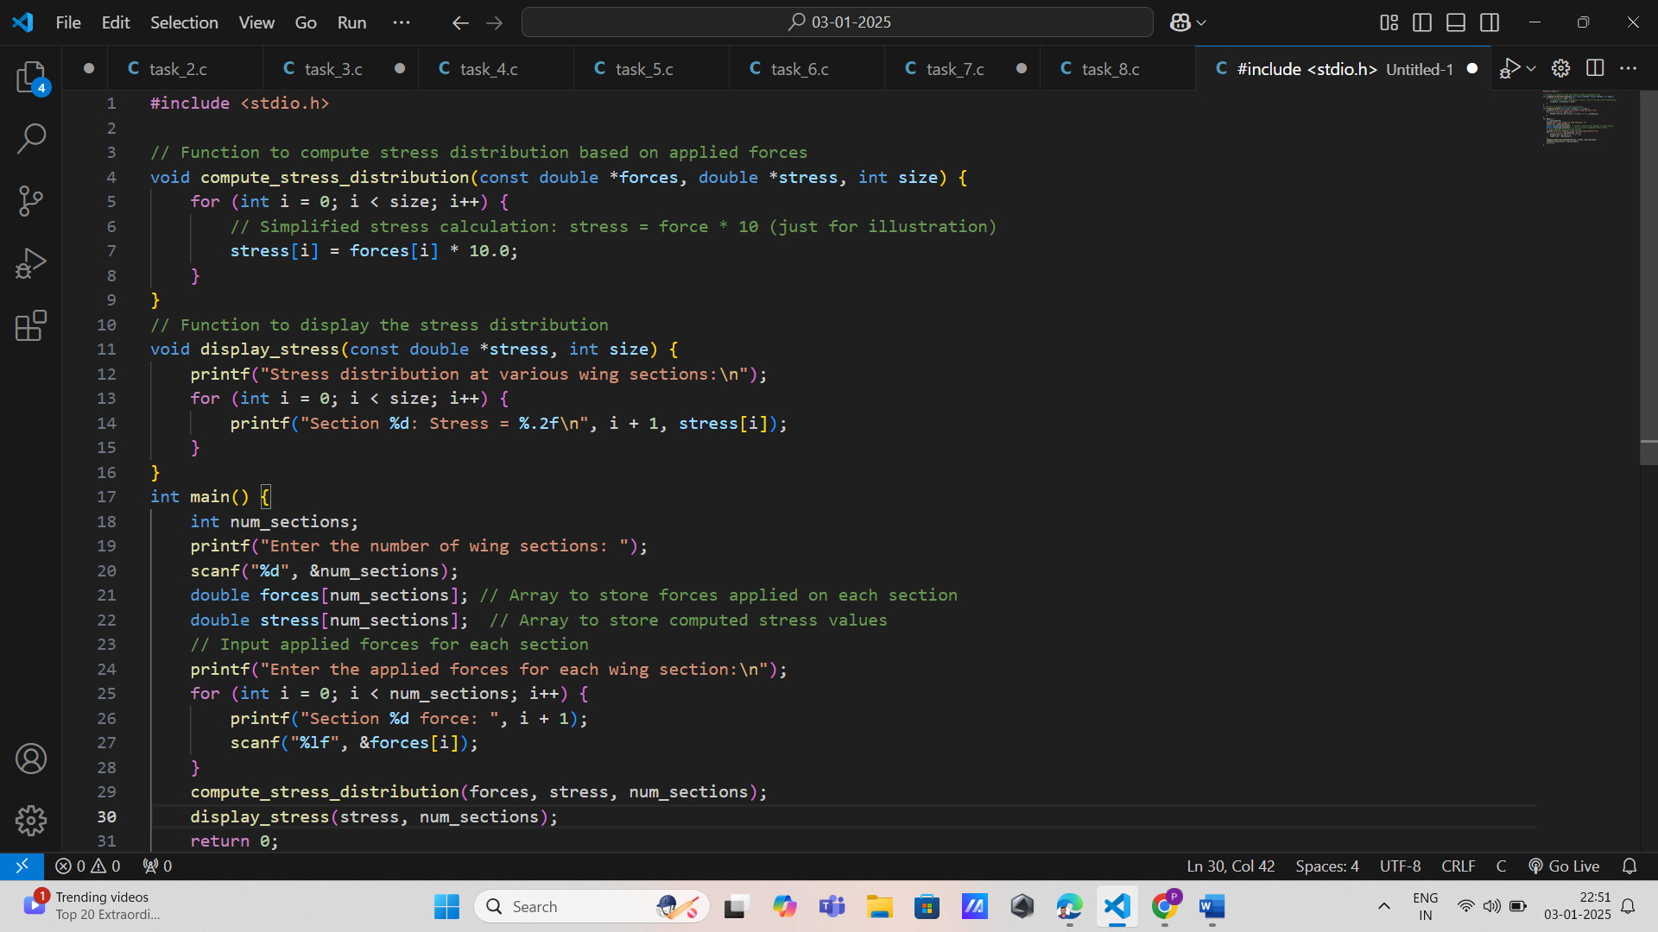

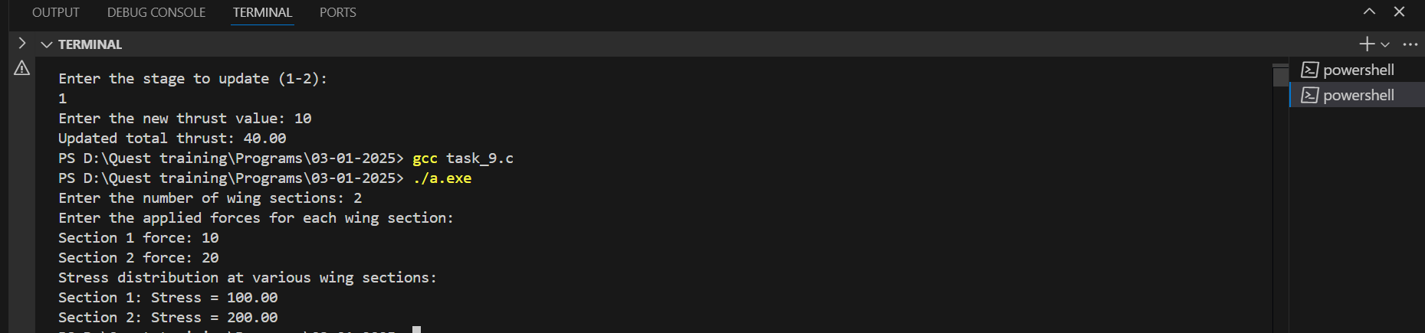

10. Drone Path Optimization

Pointers: Traverse waypoint arrays.

Arrays: Store coordinates of waypoints.

Functions:

double optimize_path(const double *waypoints, int size): Reduces the total path length.

void add_waypoint(double *waypoints, int *size, double x, double y): Adds a new waypoint.

Pass Arrays as Pointers: Use pointers to access and modify waypoints.

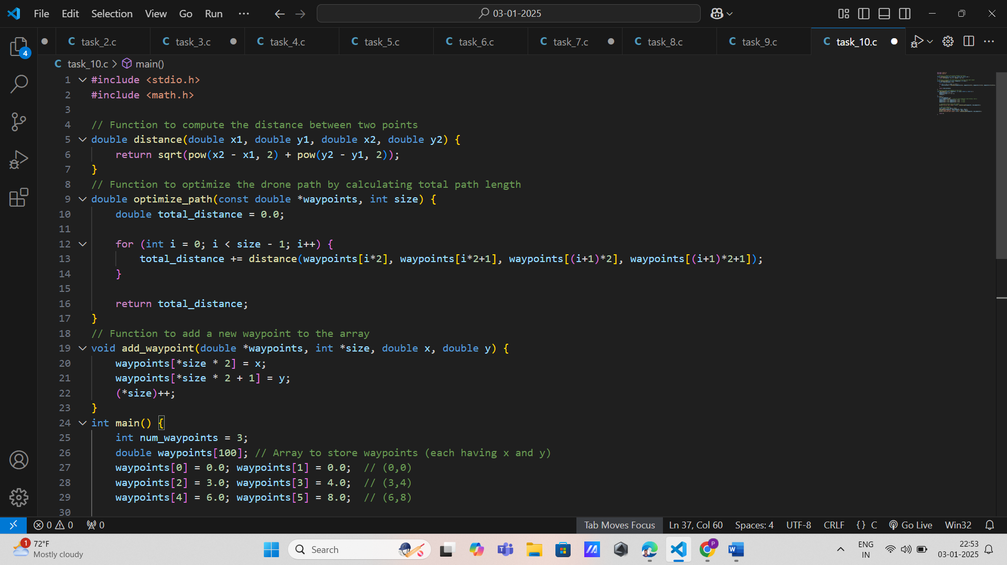

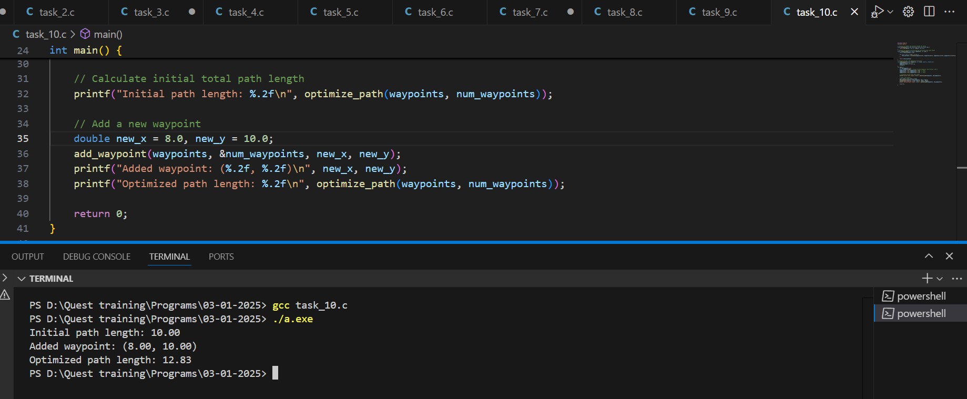

11. Satellite Attitude Control

Pointers: Manipulate quaternion arrays.

Arrays: Store quaternion values for attitude control.

Functions:

void update_attitude(const double *quaternion, double *new_attitude): Updates the satellite's attitude.

void normalize_quaternion(double *quaternion): Ensures quaternion normalization.

Pass Arrays as Pointers: Pass quaternion arrays as pointers.

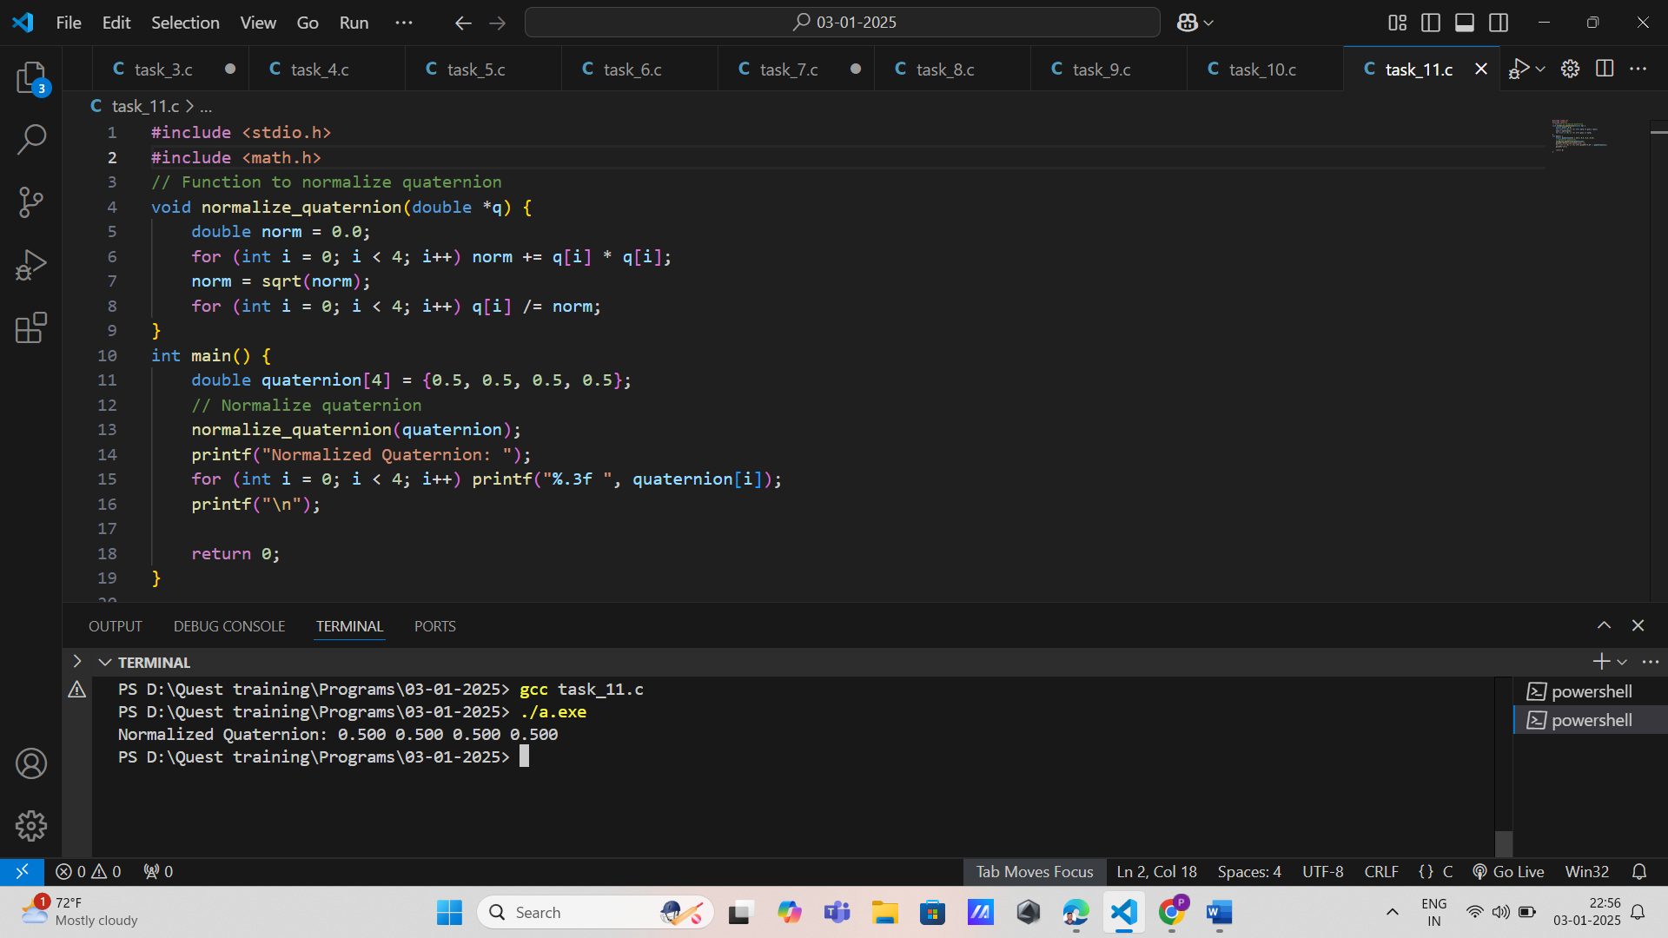

12. Aerospace Material Thermal Analysis

Pointers: Access temperature arrays for computation.

Arrays: Store temperature values at discrete points.

Functions:

void simulate_heat_transfer(const double *material_properties, double *temperatures, int size): Simulates heat transfer across the material.

void display_temperatures(const double *temperatures, int size): Outputs temperature distribution.

Pass Arrays as Pointers: Use pointers for temperature arrays.

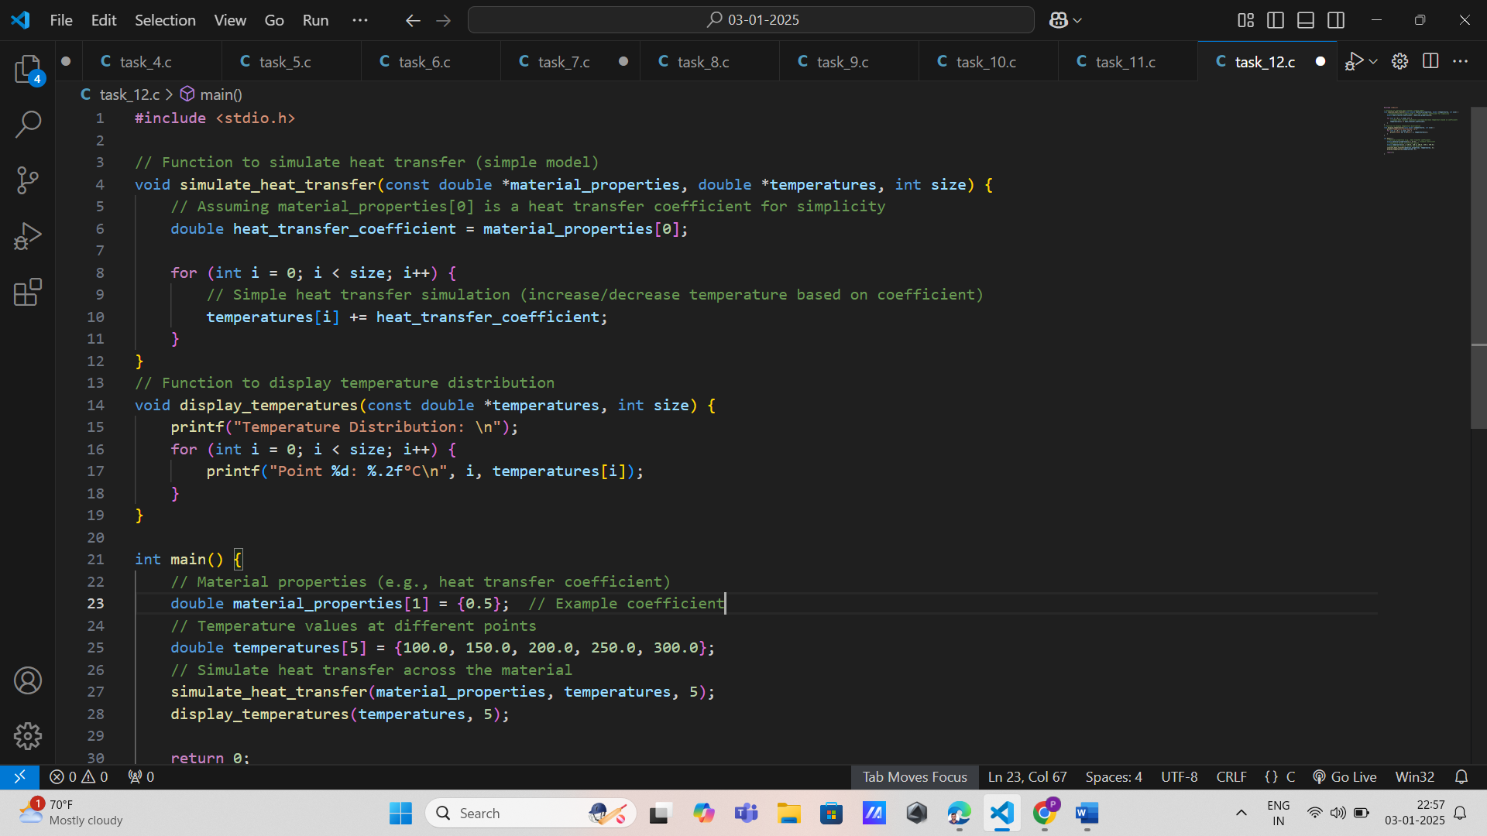

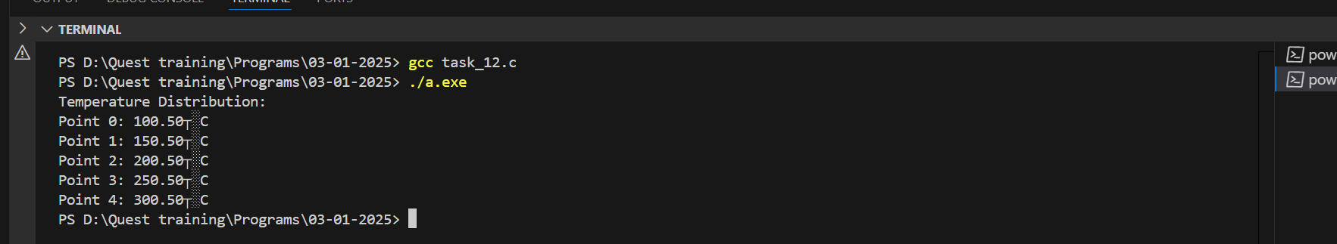

13. Aircraft Fuel Efficiency

Pointers: Traverse fuel consumption arrays.

Arrays: Store fuel consumption at different time intervals.

Functions:

double compute_efficiency(const double *fuel_data, int size): Calculates overall fuel efficiency.

void update_fuel_data(double *fuel_data, int interval, double consumption): Updates fuel data for a specific interval.

Pass Arrays as Pointers: Pass fuel data arrays as pointers.

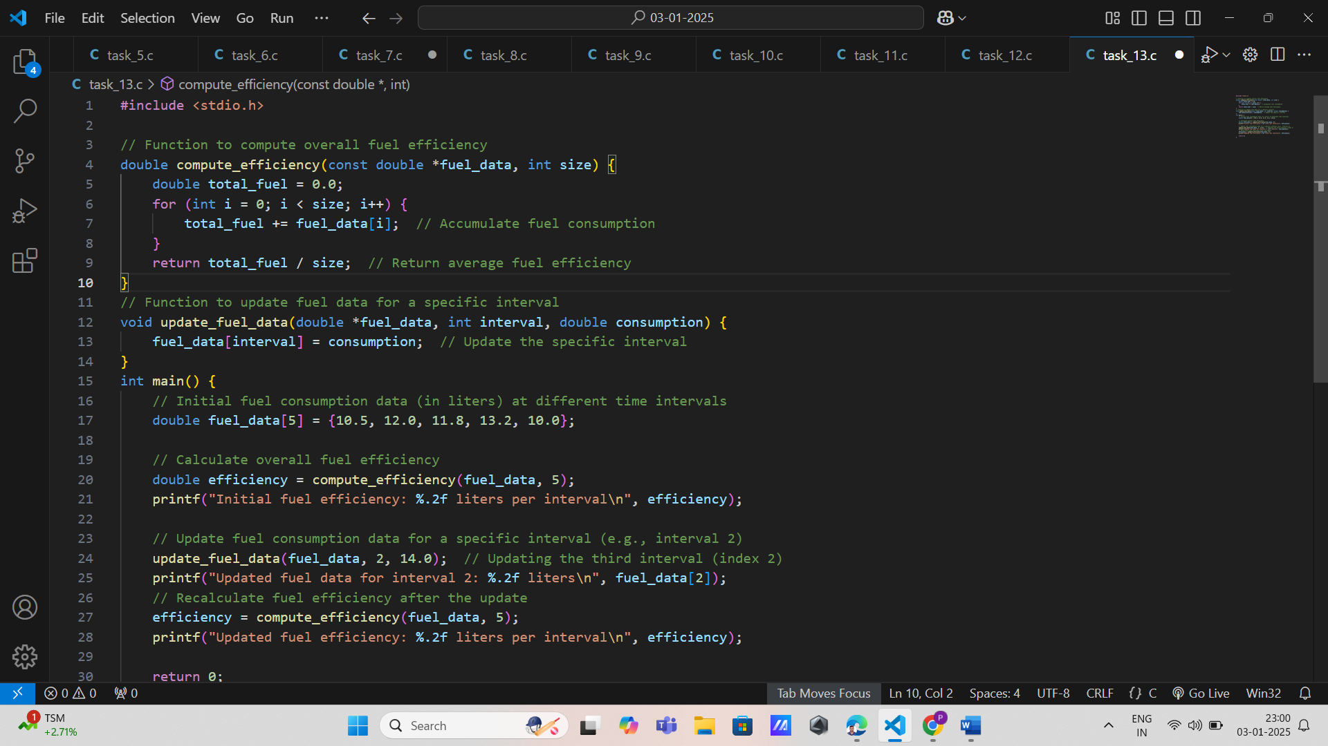

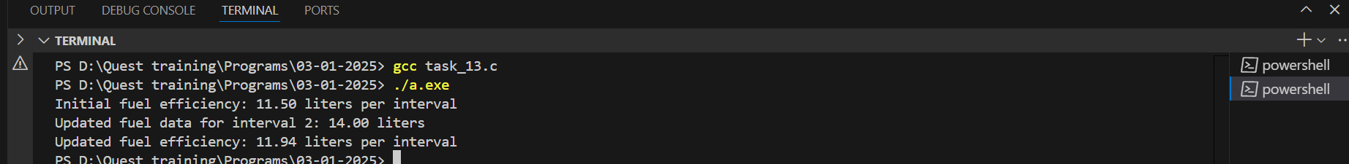

14. Satellite Communication Link Budget

Pointers: Handle parameter arrays for computation.

Arrays: Store communication parameters like power and losses.

Functions:

double compute_link_budget(const double *parameters, int size): Calculates the total link budget.

void update_parameters(double *parameters, int index, double value): Updates a specific parameter.

Pass Arrays as Pointers: Pass parameter arrays as pointers.

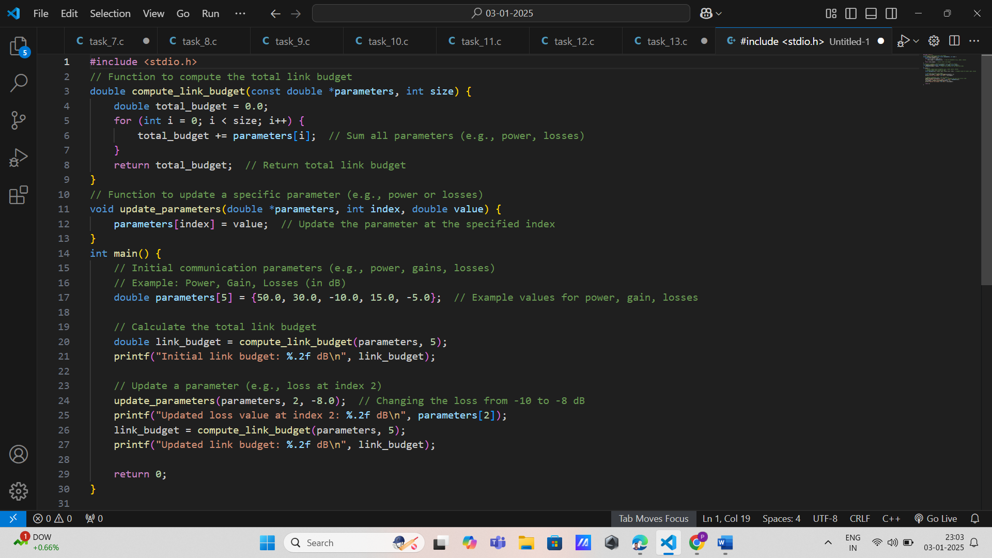

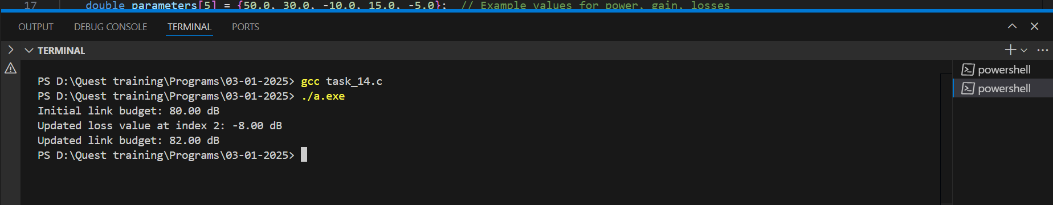

15. Turbulence Detection in Aircraft

Pointers: Traverse acceleration arrays.

Arrays: Store acceleration data from sensors.

Functions:

void detect_turbulence(const double *accelerations, int size, double *output): Detects turbulence based on frequency analysis.

void log_turbulence(double *turbulence_log, const double *detection_output, int size): Logs detected turbulence events.

Pass Arrays as Pointers: Pass acceleration and log arrays to functions.

